Sprint 1 - Endurance Design Document

November 12, 2020
Table of Contents
1. Executive Summary 3
1.1 Project Overview 3
1.2 Purpose and Scope of this Specification 3
2. Product/Service Description 3
2.1 Product Context 3
2.2 User Characteristics 3
2.3 Assumptions 3
2.4 Constraints 3
2.5 Dependencies 4
3. Requirements 4
3.1 Functional Requirements 5
3.2 Security 5
3.2.1 Protection 5
3.2.2 Authorization and Authentication 6
3.3 Portability 6
4. Requirements Confirmation/Stakeholder sign-off 6
5. System Design 6
5.1 Algorithm 6
5.2 System Flow 6
5.3 Software 6
5.4 Hardware 6
5.5 Test Plan 7
5.6 Task List/Gantt Chart 7
5.7 Staffing Plan 7

Executive Summary

Project Overview
The Sphero robot should follow the rectangular path in room HH208. The robot will start by saying “ready set go” and proceed through the path with a green light until the point of completion, which is also the starting point of the rectangle. At this point, the robot will turn red and say “I’m done and I need water”. There is further reference here.

Purpose and Scope of this Specification
In scope
- Audience: new programmers
- Purpose: learn how to use block code and deal with control flow
Out of Scope
This product specification is for the robot to follow a rectangular path. This is not the version where the robot will be moving in a figure-8 or across an obstacle course. Those versions will be in following updates.

Product/Service Description
In this section, describe the general factors that affect the product and its requirements. This section should contain background information, not state specific requirements (provide the reasons why certain specific requirements are later specified).

Product Context
How does this product relate to other products? Is it independent and self-contained? Does it interface with a variety of related systems? Describe these relationships or use a diagram to show the major components of the larger system, interconnections, and external interfaces.

User Characteristics
Create general customer profiles for each type of user who will be using the product. Profiles should include:
- Student/faculty/staff/other
- experience
- technical expertise
- other general characteristics that may influence the product

Assumptions
List any assumptions that affect the requirements, for example, equipment availability, user expertise, etc. For example, a specific operating system is assumed to be available; if the operating system is not available, the Requirements Specification would then have to change accordingly.

Constraints
There are no constraints. Most of the software was designed in a dorm room before transferred to on-site production. All software adapted correctly when designing the final product.

Dependencies
- The block code needs to be created for the robot to run
- Room HH208 needs to be accessed in order to test the program
- One of the group members needs to be on campus in order to retrieve the robot used for testing
- A secure WIFI connection needs to be established in order to connect the personal computer and the robot

Requirements

Functional Requirements
Req# | Requirement | Comments | Priority | Date Rvwd | SME Reviewed / Approved
ENDUR_01 | Start program on yellow square | Required by (CEO) Eckert. | 1 | 10/28/20 | 11/12/20
ENDUR_02 | Set light to green | Required by (CEO) Eckert. | 1 | 10/28/20 | 11/12/20
ENDUR_03 | Speak “ready set go” | Required by (CEO) Eckert. | 1 | 10/28/20 | 11/12/20
ENDUR_04 | Move straight | Required by (CEO) Eckert. | 1 | 10/28/20 | 11/12/20
ENDUR_05 | Move right | Required by (CEO) Eckert. | 1 | 10/28/20 | 11/12/20
ENDUR_06 | Move backwards | Required by (CEO) Eckert. | 1 | 10/28/20 | 11/12/20
ENDUR_07 | Move left | Required by (CEO) Eckert. | 1 | 10/28/20 | 11/12/20
ENDUR_08 | Set light to red | Required by (CEO) Eckert. | 1 | 10/28/20 | 11/12/20
ENDUR_09 | Speak “I’m done and I need water” | Required by (CEO) Eckert. | 1 | 10/28/20 | 11/12/20

Security

Protection
Specify the factors that will protect the system from malicious or accidental access, modification, disclosure, destruction, or misuse. For example:
- encryption
- activity logging, historical data sets
- restrictions on intermodule communications
- data integrity checks

Authorization and Authentication
Specify the Authorization and Authentication factors. Consider using standard tools such as PubCookie.

Portability
- The block code is shared as a png file through github on a public repository, so it can be accessed and replicated by anyone
- Block code is understood by any level programmer, so it is easily comprehendible
  - Underneath the block code is JavaScript, but the programmer does not need to know how to code in JavaScript in order to complete the block code
- Sphero program on the personal computer can be accessed by any operating system

Requirements Confirmation/Stakeholder sign-off
Meeting Date | Attendees (name and role) | Comments
11/10/20 | Zoë (COO), Maryam (PM), Keven (PM) | Reviewed and confirmed all requirements as a group.

System Design

Algorithm
- Start program on yellow square
- Set light to green
- Speak “ready set go”
- Move straight
- Move right
- Move backwards
- Move left
- Set light to red
- Speak “I’m done and I need water”

System Flow
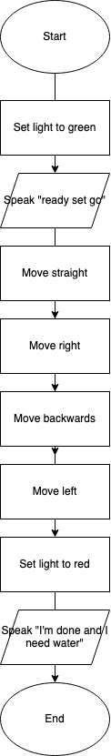

Software
Block code representing JavaScript code was manipulated using Sphero Edu software.
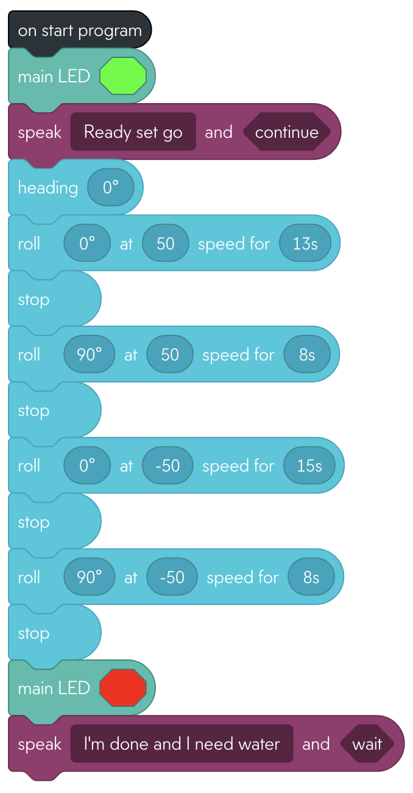
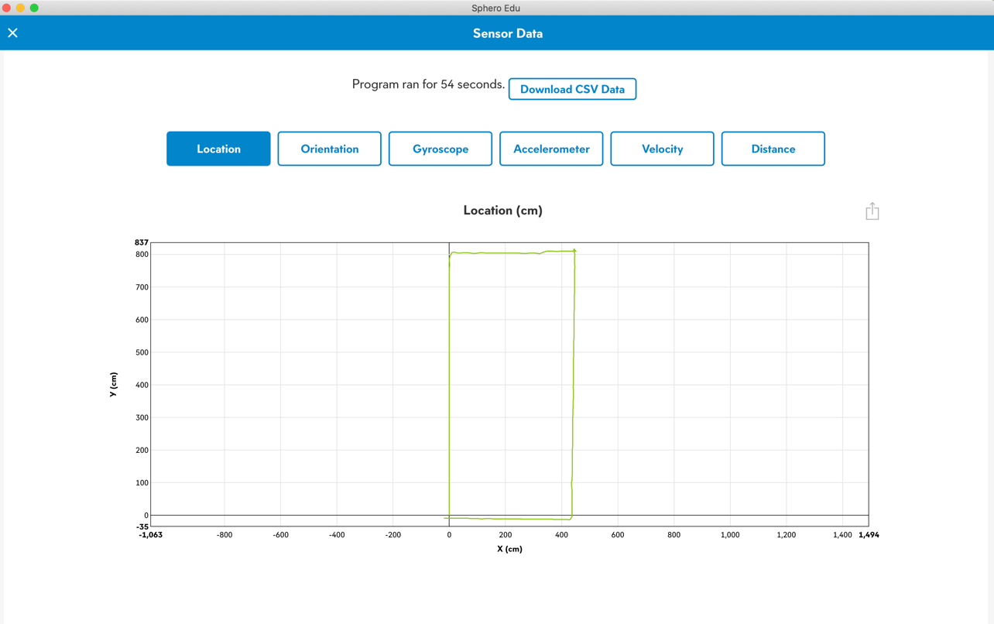
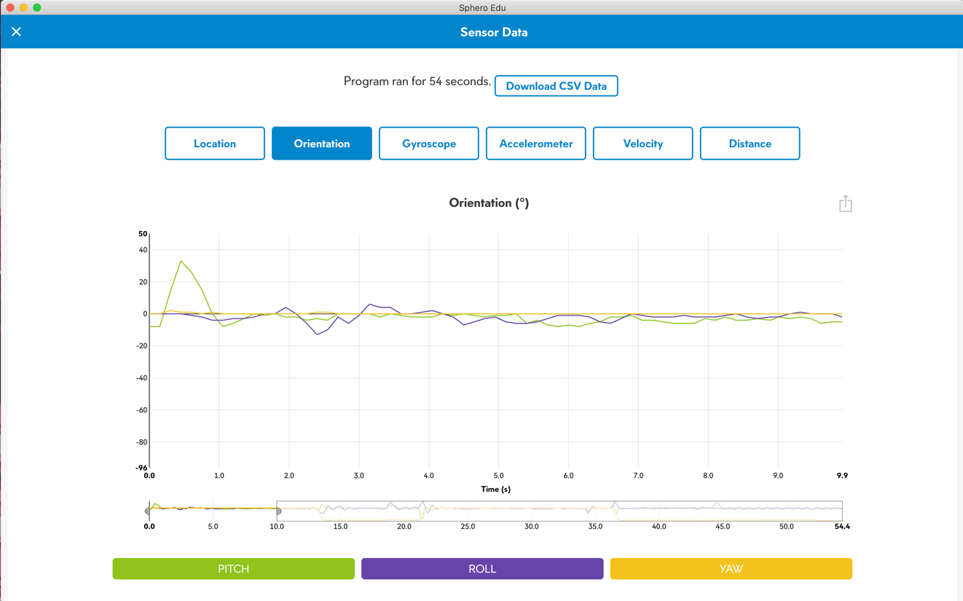

Hardware
The Sphero robot was used in testing. The version used was the SPRK+ and connected to a personal computer over Bluetooth in order to access the block code created by the COO.

Test Plan
Reason for Test Case | Test Date | Expected Output | Observed Output | Staff Name | Pass/Fail
First Test | 10/27/20 | Some errors, unknown | Went too far on both directions of the rectangle | Zoë | Pass
Shorten length of movement by shortening seconds of motion | 10/27/20 | Shortened length | Hit the wall, not calibrated correctly | Zoë | Fail
Fix calibration | 10/27/20 | Followed path | Strayed inward on the rectangle, not calibrated correctly | Zoë | Fail
Fix calibration | 10/28/20 | Followed path | Short 3rd distance, almost accurate | Zoë | Fail
Fix calibration | 10/28/20 | Followed path | Short 3rd distance, bumped into a couple of objects | Zoë | Fail
Fix calibration | 10/28/20 | Followed path | One bump, but still very accurate, within reason | Zoë | Pass

Task List/Gantt Chart
Embed your gantt chart here

Staffing Plan
Name | Role | Responsibility | Reports To
Zoë Klapman | COO, software developer | Oversee operations, program/test robot | (CEO) Professor Eckert
Keven Kevelier | PM | Monitor task list/gantt chart | (COO) Zoë Klapman
Maryam Kakar | PM | Monitor task list/gantt chart | (COO) Zoë Klapman

